

CMPG321

Homework Assignment 1

27347435

DB Nel

Submission Date: 03/09/2021

The submission is solely my own work – DB Nel - 27347435

Table of Contents

1. MISTAKES IN THE GIVEN DATABASE 2

2. CONCEPTUAL DESIGN 2

3. LOGICAL DESIGN 2

4. PHYSICAL DESIGN 3

4.1 Users 3

4.2 Indexing Strategy 4

# MISTAKES IN THE GIVEN DATABASE

The following mistakes were made in the example database:

* The database is not in 3rd normal form;
* Data anomalities will occur when updating:
  + Artist
  + Album
  + Year
* A genre can be one or more genre;
* Genre is listed as POP and pop, you must always be consistent in naming conventions;
* A problem could arise when there is a feature artist, i.e. Taylor Swift fear. Kendrick, there must be a clear distinction between the main artist and the featuring artist.

# CONCEPTUAL DESIGN

The following conceptual design was created:

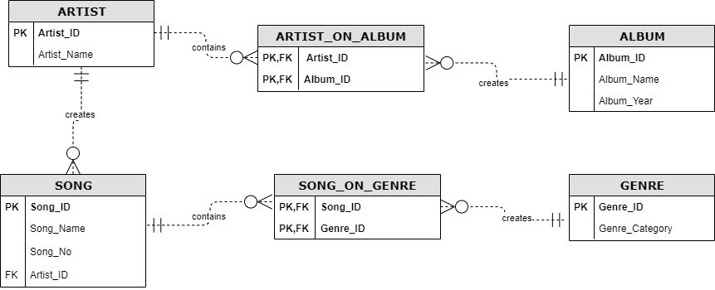

# LOGICAL DESIGN

The logical design SQL code:

|  |
| --- |
| CREATE TABLE artist    (       artist_id   INT NOT NULL,       artist_name VARCHAR(50) NOT NULL,       CONSTRAINT pk_artist_id PRIMARY KEY (artist_id)    );  CREATE TABLE album    (       album_id    INT NOT NULL,       artist_name VARCHAR(50) NOT NULL,       CONSTRAINT pk_album_id PRIMARY KEY (album_id)    );  CREATE TABLE song    (       song_id   INT NOT NULL,       song_name VARCHAR(50) NOT NULL,       song_no   INT NOT NULL,       artist_id INT NOT NULL,       CONSTRAINT pk_song_id PRIMARY KEY (song_id),       CONSTRAINT fk_artist_id FOREIGN KEY (artist_id) REFERENCES artist (       artist_id)    );  CREATE TABLE genre    (       genre_id       INT NOT NULL,       genre_category VARCHAR(50) NOT NULL,       CONSTRAINT pk_genre_id PRIMARY KEY (genre_id)    );  CREATE TABLE song_on_genre    (       song_id  INT NOT NULL,       genre_id INT NOT NULL,       CONSTRAINT pk_song_id_genre_id PRIMARY KEY(song_id, genre_id),       CONSTRAINT fk_song_id FOREIGN KEY (song_id) REFERENCES song (song_id),       CONSTRAINT fk_genre_id FOREIGN KEY (genre_id) REFERENCES genre (genre_id)    );  CREATE TABLE artist_on_album    (       artist_id INT NOT NULL,       album_id  INT NOT NULL,       CONSTRAINT pk_artist_id_album_id PRIMARY KEY (artist_id, album_id),       CONSTRAINT fk_artist_id FOREIGN KEY (artist_id) REFERENCES artist (       artist_id),       CONSTRAINT fk_album_id FOREIGN KEY (album_id) REFERENCES album (album_id)    ); |

# PHYSICAL DESIGN

## Users

* + 1. Database Administrator
    2. Parametric End Users
    3. System Analyst
    4. Database Designers
    5. Sophisticated Users
    6. Temporary Users

## Indexing Strategy

* + 1. Table access: when searching for a genre/specific artist